Midterm EXAMINATION

Name: Qingjun Bao

ID: 222-8801

**Time Allowed:75 Minutes** **Total Marks: 30**

**Note:**

* There are 18 problems, divided into two parts.
* Give a solution to each of the problems 1 to 10 in the file provided.
* Give a solution to each of the problems11 and 18 in an **linux and take screenshots**
* You must upload the files before the time is finished. Otherwise, no marks will be considered.

**Marking Scheme:**

* Problems 1 to 10, 10 * 1 = 10. There are no partial marks.
* Problems 11 to 18, 8 * 2.5 = 20 . There are partial marks depending on the correctness of the solution.

|  |  |
| --- | --- |
| **Student First Name:** | Qingjun |
| **Student Last Name:** | Bao |
| **Student ID:** | 222-8801 |

## Part 01

C) 1-What command is used to list contents of directories

1. Tar
2. Ip
3. Ls
4. Non of the above

D) 2-Which of the following command is used to change the working directory?

1. changed
2. chdr
3. dr
4. cd

B) 3-Linux Kernel was founded by?

1. Richard Stallman
2. Linus Torvalds
3. Bill Gates
4. Ben Thomas

B) 4-Which of the following is used to represent the top-level directory?

1. ~
2. /
3. $
4. #
5. 5-Where is the user creation stored?
6. /etc/passwd
7. /root/passwd
8. /etc/user
9. /root/user
10. 6-What is the core of the Linux operating system?
11. Terminal
12. Kernel
13. Command
14. Processor

D) 7- Which of the following is nonvolatile?

a) register

b) cache

c) main memory

d) hard-disk drive

A) 8-One important principle is the separation of policy from mechanism.

a)True

b)False

C) 9-The redirection 2>abc implies

a)Write file2 to file abc

b)write standard output to abc

c)Write standard error to abc

d)None of the mentioned

B) 10-Which of the following storage medium is the slowest regarding access speed?

a) cache

b) solid state drive

c) register

d) main memory

## Part 02

1. Create user student1 and group class1, change the primary group of student1 to be class1.

# adduser student1

# addgroup class1

# usermod –g class1 student1

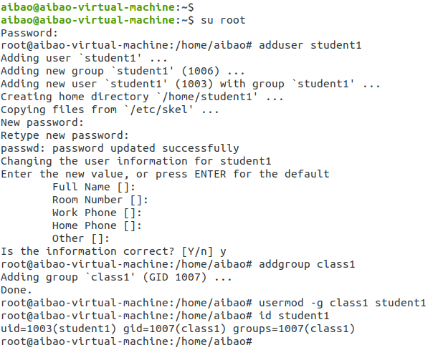

1. Create a file (files) from student1 access, check who is the owner user and who is the owner group.

# su student1

$ touch file1

$ ls –l file1

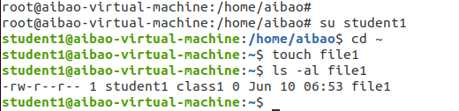

1. create a file filex, then using the numerical method to change the permission to be,

for user (read and write) 6

for group (read and execute) 5

for other (read only) 4

$ touch filex

$ chmod 654 filex

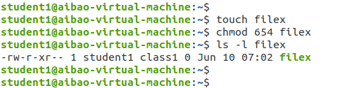

1. create a directory Myfinal, and copy filex inside, then use the symbolic method to change the permission of the directory and the file inside (in one step) to be

for user (read, write, and execute)

for group (read and write)

for other (non)

$ mkdir Myfinal

$ cp filex Myfinal

$ chmod –R u=rwx,g=rw,o=- Myfinal

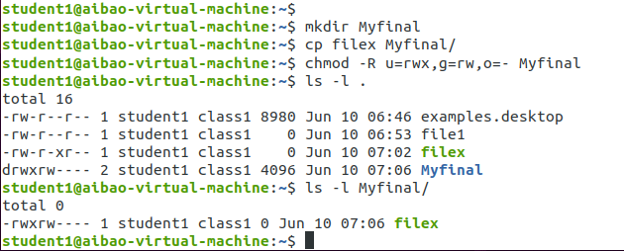

1. Create file “filetest” and write “Hello Could you help me with the file”

$ cat > filetest

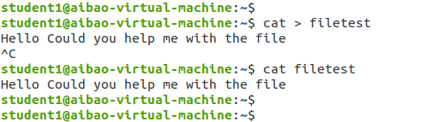

1. Get the content of “filetest” and file “exam” and put the good output in “result” and the error in “error”

$ cat filetest exam 1>result 2>error

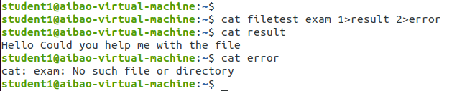

1. Append “thank you for your help” in “filetest”

$ cat >> filetest

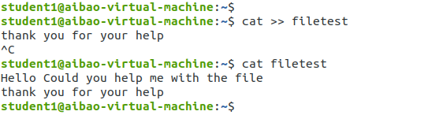

1. Copy this file “filetest” to Myfinal softlink and hardlink, show the difference between two methods.

$ ln –s filetest Myfinal/filetest2

$ ln filetest Myfinal

$ ls -li

